Lab 4 Report: Informed Search — Heuristics & A*
Course: CS4944 / CA1601400 Artificial Intelligence Lab | Week 4 | CLO2 (C3: Apply)

Objective
The aim of this lab is to use the heuristic evaluation formula f(n) = g(n) + h(n) and A* search on a weighted campus-routing graph. It also checks whether the heuristic is admissible and consistent, and compares A* with UCS and with a heuristic that overestimates the remaining cost.

1. Problem Statement, Unit Assumptions, and Counting Convention
The campus-routing graph has buildings S (the start), A, B, C, and G (the goal). The directed edges and travel-time costs are S->A(1), S->B(4), A->C(2), B->G(5), and C->G(3). These edge weights represent abstract travel-time units, so each heuristic value h(n) must estimate the remaining time in the same units. Straight-line distance in metres cannot be added directly to travel time. Following Section 4.6, a node is counted as expanded only when its successors are examined. The goal G is included in the processed trace when it is popped, but it is not included in the expansion count. Stale priority-queue entries (where g != best[node]) are ignored.
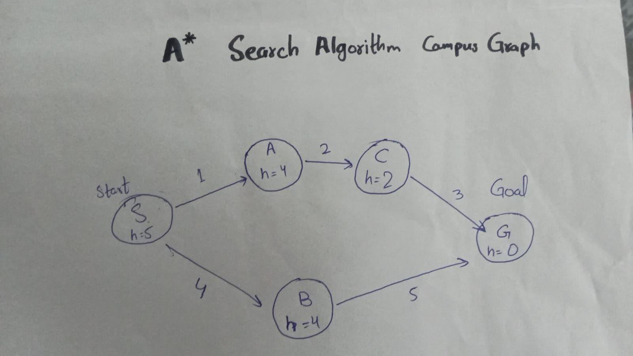

2. Task 1: Heuristic Admissibility/Consistency Audit and Manual First-Three Expansions
There are two complete routes from S to G. The route S->A->C->G costs 1 + 2 + 3 = 6 and is the optimal route. The alternative S->B->G costs 4 + 5 = 9. These routes give the true remaining costs h*(n): S:6, A:5, B:5, C:3, and G:0. I compared the supplied heuristic h = {S:5, A:4, B:4, C:2, G:0} with those true costs and checked every directed edge using h(u) <= cost(u,v) + h(v). The heuristic passes both tests: it is admissible because it never overestimates the remaining cost, and consistent because it satisfies the condition on every edge. The manual calculations for the first three expansions (S, A, and C) also match the priority-queue trace in lab4_astar_audit.py. They place G at f=6 ahead of B at f=8.
Audit Type / Item | Node or Edge | Supplied Value(s) | Comparison Target / RHS | Condition Checked | Result
Admissibility | Node S | h(S) = 5 | h*(S) = 6 (via S->A->C->G) | 5 <= 6 | Pass (Admissible)
Admissibility | Node A | h(A) = 4 | h*(A) = 5 (via A->C->G) | 4 <= 5 | Pass (Admissible)
Admissibility | Node B | h(B) = 4 | h*(B) = 5 (via B->G) | 4 <= 5 | Pass (Admissible)
Admissibility | Node C | h(C) = 2 | h*(C) = 3 (via C->G) | 2 <= 3 | Pass (Admissible)
Admissibility | Node G | h(G) = 0 | h*(G) = 0 (Goal) | 0 <= 0 | Pass (Admissible)
Consistency | Edge S -> A (w=1) | h(S) = 5, h(A) = 4 | cost(S,A) + h(A) = 1 + 4 = 5 | 5 <= 5 | Pass (Consistent)
Consistency | Edge S -> B (w=4) | h(S) = 5, h(B) = 4 | cost(S,B) + h(B) = 4 + 4 = 8 | 5 <= 8 | Pass (Consistent)
Consistency | Edge A -> C (w=2) | h(A) = 4, h(C) = 2 | cost(A,C) + h(C) = 2 + 2 = 4 | 4 <= 4 | Pass (Consistent)
Consistency | Edge B -> G (w=5) | h(B) = 4, h(G) = 0 | cost(B,G) + h(G) = 5 + 0 = 5 | 4 <= 5 | Pass (Consistent)
Consistency | Edge C -> G (w=3) | h(C) = 2, h(G) = 0 | cost(C,G) + h(G) = 3 + 0 = 3 | 2 <= 3 | Pass (Consistent)

Expansion Step | Selected Node | Arithmetic for Selected Node (g, h, f=g+h) | Successor Calculations & Remaining Frontier Entries | Why Next Node is Selected
Expansion 1 | S (path ['S']) | g(S)=0  h(S)=5  f(S)=0+5=5 | A: g=0+1=1, h=4, f=1+4=5  B: g=0+4=4, h=4, f=4+4=8  Frontier: [(5, 1, 'A', ['S','A']), (8, 4, 'B', ['S','B'])] | A has the lowest f-value: 5 < 8, so A is popped next.
Expansion 2 | A (path ['S','A']) | g(A)=1  h(A)=4  f(A)=1+4=5 | C: g=1+2=3, h=2, f=3+2=5  Frontier: [(5, 3, 'C', ['S','A','C']), (8, 4, 'B', ['S','B'])] | C has the lowest f-value: 5 < 8, so C is popped next.
Expansion 3 | C (path ['S','A','C']) | g(C)=3  h(C)=2  f(C)=3+2=5 | G: g=3+3=6, h=0, f=6+0=6  Frontier: [(6, 6, 'G', ['S','A','C','G']), (8, 4, 'B', ['S','B'])] | G has f=6, which is lower than B's f=8. G is popped next and logged as the processed goal, but it is not expanded. B remains unexpanded.

3. Task 2: Controlled Comparison of A* vs. Zero-Heuristic UCS Control (lab4_astar_audit.py, lab4_ucs.py)
For the UCS control run, I set h(n) = 0 for every node while keeping the same priority-queue implementation, graph, start and goal nodes, and tie-breaking rules. Both A* and UCS return the optimal path ['S', 'A', 'C', 'G'], with a verified cost of 6. Neither algorithm encounters stale entries on the base graph. A* expands only 3 nodes (['S', 'A', 'C']). Since h(B)=4, B has f=8, which is greater than the goal's cost of 6. UCS uses path cost alone. Because g(B)=4 is less than g(G)=6, UCS expands B as its fourth expansion before the goal is popped.
Run / Algorithm | Returned Path | Reported Cost g(G) | Independent Cost Sum | Processed-Node Trace (Includes Goal G) | Expanded Nodes (Excludes Goal G) | Expansion Count
A* (Supplied Admissible h) | ['S', 'A', 'C', 'G'] | 6 | 1 + 2 + 3 = 6 | ['S', 'A', 'C', 'G'] (4 processed) | ['S', 'A', 'C'] | 3
UCS Control (Zero Heuristic h=0) | ['S', 'A', 'C', 'G'] | 6 | 1 + 2 + 3 = 6 | ['S', 'A', 'C', 'B', 'G'] (5 processed) | ['S', 'A', 'C', 'B'] | 4
A* Overestimate (h(C) = 10) | ['S', 'B', 'G'] (Suboptimal) | 9 | 4 + 5 = 9 | ['S', 'A', 'B', 'G'] (4 processed) | ['S', 'A', 'B'] | 3

4. Task 3: Single-Value Overestimation Experiment (h(C) Changed from 2 to 10)
I changed only h(C), from 2 to 10, even though the true remaining cost is h*(C)=3. This breaks admissibility because 10 > 3. It also breaks consistency on edge C->G because 10 > 3 + 0. After S (f=5) and A (f=5) are expanded, C enters the queue with g(C)=3, h(C)=10, and f(C)=13. This is higher than B's f(B)=8, so A* expands B next. It then adds G through S->B->G with f(G)=9, which is lower than C's f=13. A* stops with the suboptimal path ['S', 'B', 'G'] at cost 9, while C remains in the queue unexpanded. A smaller overestimate, such as h(C)=4, would give f(C)=7, which is still below B's f=8 and might leave the returned path unchanged on this graph. However, once a heuristic is inadmissible, the theoretical guarantee that the first goal popped is optimal no longer applies.

5. Edge-Case Analysis: Start==Goal, Unreachable Goal, and Stale Queue Filtering
Edge Case Test | Input Configuration | Observed Behavior | Explanation & Proposed Improvement
1. Start Equals Goal (S -> S) | CAMPUS_GRAPH, start='S', goal='S' | path=['S'], cost=0, processed=['S'], expanded=[], expansion_count=0. | The goal is recorded as processed, but it is not counted as an expanded node.
2. Unreachable Goal (S -> Z) | CAMPUS_GRAPH with isolated node Z (h(Z)=0) | path=None, cost=None, processed=['S','A','C','G','B'], expansion_count=5. | The queue becomes empty after all reachable vertices have been expanded.
3. Stale Priority-Queue Entry (lab4_ucs.py) | Graph S->A(1), S->B(10), A->B(2), B->G(10) | B is first queued at g=10 from S, then improved to g=3 through A. The stale entry (10,10,'B',['S','B']) is skipped. | The g != best[node] check prevents B from being expanded again when the old entry is later popped at cost 10.

6. Reflection, Responsible Practice, and Conclusion

Reflection
I learned that an admissible heuristic can help A* avoid less promising branches, such as B in this example, while still finding the optimal route. When h(C) was increased to 10, A* returned a route costing 9 instead. In a real navigation system, I would make sure all values use compatible units. For example, straight-line distance would need to be converted into a time estimate using maximum travel speed. I would also run automated checks for heuristic consistency across the graph's edges. One result that stood out was that the inflated heuristic still led A* to expand 3 nodes, but it returned a more expensive route. In the next test, I would examine how tie-breaking affects the search when two frontier paths have the same f-value.

Responsible Practice & Conclusion
All expansion counts were taken from instrumented program traces. The same counting rules were used for both A* and UCS, so their results can be compared consistently.

7. References
1. Hart, P. E., Nilsson, N. J., & Raphael, B. (1968). A Formal Basis for the Heuristic Determination of Minimum Cost Paths. IEEE Transactions on Systems Science and Cybernetics, 4(2), 100-107.
2. Russell, S., & Norvig, P. (2020). Artificial Intelligence: A Modern Approach (4th ed., Section 3.5: Informed (Heuristic) Search Strategies). Pearson.
3. CS4944 / CA1601400 Artificial Intelligence Lab Manual, Lab 4: Informed Search: Heuristics & A* (Guided A* implementation adapted from Section 4.2).

